**ELECTIVE 3**

Midterm Exam

**Image Processing in Octave**

|  |
| --- |
|  |

Score

*Submitted by:*

**Santago, Christian Timothy D.**

**BSCPE / 4 - 2**

*Date Submitted*

**24-11-2022**

*Submitted to:*

**Engr. Maria Rizette H. Sayo**

Methodology

1. Importing, Displaying, and Converting Images
2. Using the Editor of Octave, create a program that will load and display parrots.jpg
3. Examine the size of the parrots by typing whos to find out the size of the image that you have read in
4. Convert the class uint8 color image parrots to a gray scale image, and display the full intensity range gray-scale image using the imshow command
5. Covert the true color image to a gray-scale image
6. Save the program to this format parrots.m
7. Display of Color Images
8. Open the image file nature.jpg from the source folder
9. Read in the file nature.jpg and display it on the screen as a reference image How large an image is created when we use the RGB representation compared to a gray-scale image conversion of it?
10. Assign an image color that intensifies red, green, and blue and display each image in one window
11. Convert each image file extension to png
12. Save the program as nature.jpg

*Note: Take a screen shot of the output display of the converted images and do not forget to write your Octave code to this manuscript*

Screen shot of Output Image

1. parrots

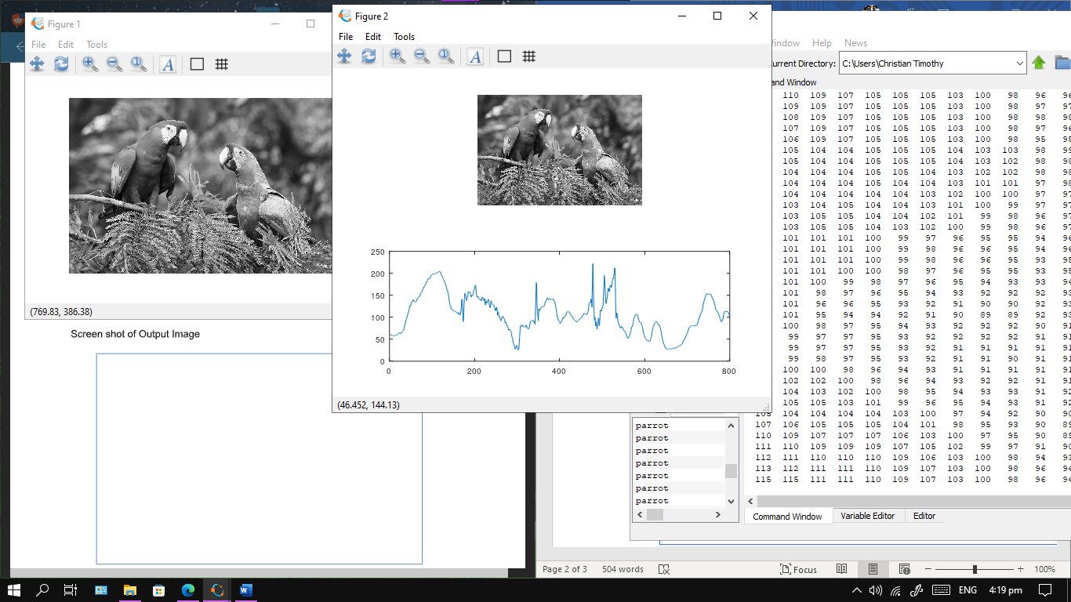

1. nature

Source Codes:

1. parrots

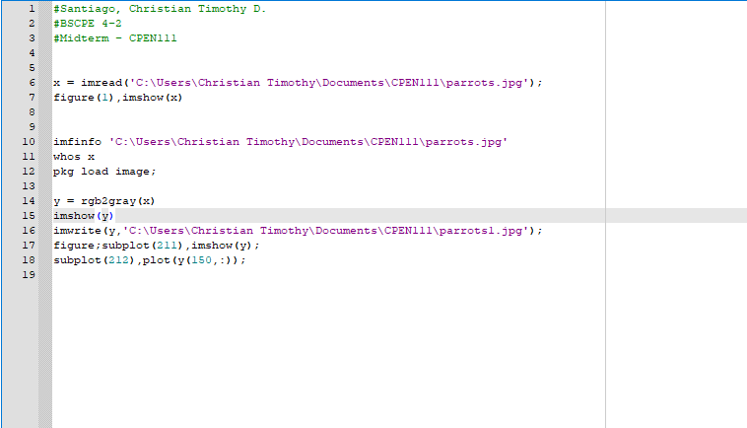

1. nature

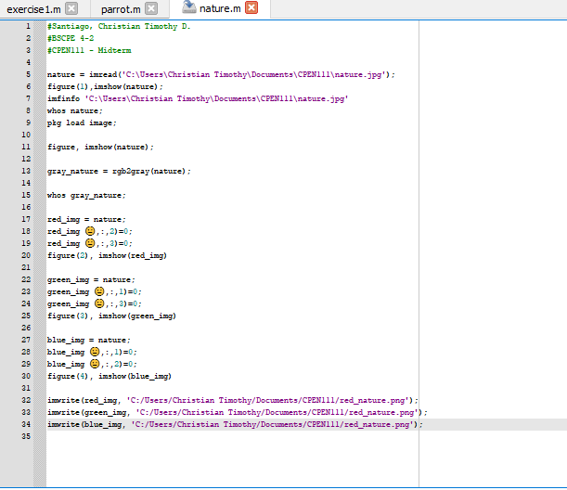

Conclusion

The codes used in the are all to show that the images can be edited and changed in a way, from viewing the information of the image to edit its values as well. The imshow command is used to show the rgb file, imread to be able to edit it, and imwrite to create changes to the image, additionally it uses commands such as rgb2gray to change the color, and uses figure as to create a graph to show the values.

*The conclusion expresses the summary of the midterm exam as perceived by the examinee*

Rubrics in Grading the Midterm Exam

|  |  |  |  |  |
| --- | --- | --- | --- | --- |
|  | A – Excellent | B – Good | C – Fair | D – Needs Improvement |
| Specifications | The Program works and meets all of the specifications | The program works and produces the correct results and displays them correctly. It also meets the most of the other specifications | The program produces correct results but does not display them correctly | The program is producing incorrect results |
| Readability | The code is exceptionally well organized and very easy to follow | The code is fairly easy to read | The code is readable only by someone who knows what it is supposed to be doing | The code is poorly organized and very difficult to read. |
| Reusability | The code could be reused as a whole or each routine could be reused | Most of the code could be reused in other programs | Some parts of the code could be reused in other programs | The code is not organized for reusability |
| Documentation | The documentation is well written and clearly explains what the code is accomplishing and how | The documentation consists of embedded comment and some simple header documentation that is somewhat useful | The documentation is simply comments embedded in the code with some simple header comments separating routines | The documentation is simply comments embedded in the code and does not help the reader understand the codes |
| Efficiency | The code is extremely efficient without sacrificing readability and understanding. | The code is fairly efficient without sacrificing readability and understanding | The code is brute force and unnecessarily long | The code is huge and appears to be patched together |
| TOTAL |  | | | |